Where Music Meets Science
DVD
Part 1 – Where Pitch and Frequency Meet
Student Study Guide

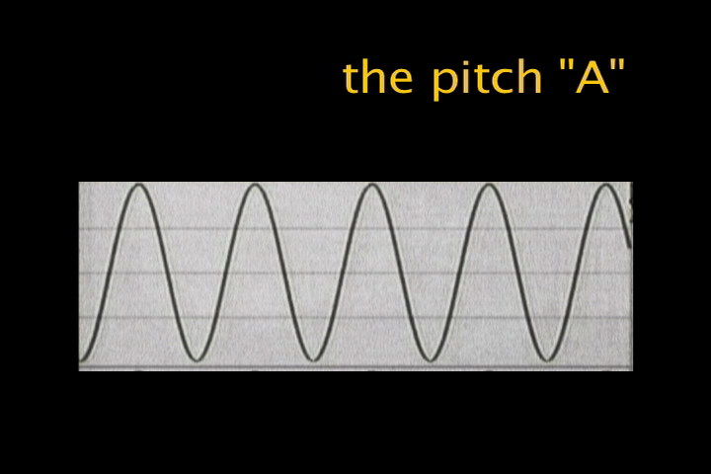

Fill in the correct answer while you watch the DVD.

1. Another name for pitch is _______________.
2. When an instrument has a high pitch it has a _____________ frequency when it has a low pitch it has a _______________ frequency.
3. Sound occurs when _______________are forced together.
4. Pitches or Frequencies move like _______________S.
5. Slow waves represent _______________ pitches.
6. Fast waves represent _______________ pitches.
7. An orchestra tunes to the frequency, _______________ Hz
8. One complete vibration of a wave is a _______________.
9. Another name for cycles per second is _______________.
10. When a pitch is one octave higher, the frequency DOUBLES.

