Where Music Meets Science
DVD
Part 1 – Where Pitch and Frequency Meet
Student Study Guide

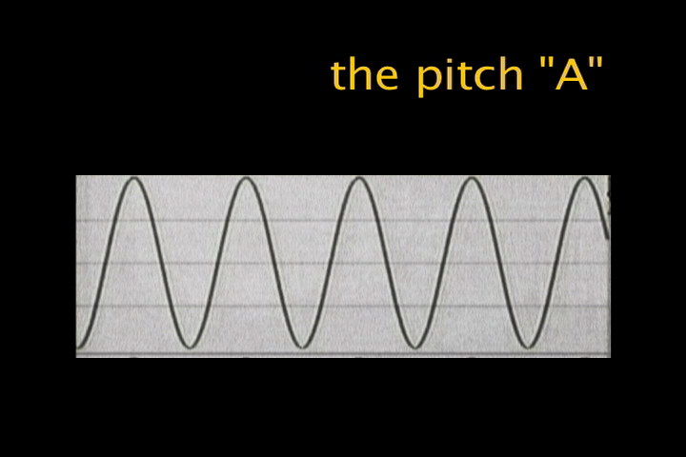

Fill in the correct answer while you watch the DVD.

1. Another name for pitch is FREQUENCY.
2. When an instrument has a high pitch it has a High Frequency when it has a low pitch it has a Low Frequency.
3. Sound occurs when air molecules are forced together.
4. Pitches or Frequencies move like WAVES.
5. Slow waves represent LOW pitches.
6. Fast waves represent HIGH pitches.
7. An orchestra tunes to the frequency, 440 Hz
8. One complete vibration of a wave is a CYCLE.
9. Another name for cycles per second is HERTZ or Hz.
10. When a pitch is one octave higher, the frequency DOUBLES.

