Where Music Meets Science
DVD
Part 2 – Timbre and Complex Waves
Student Study Guide

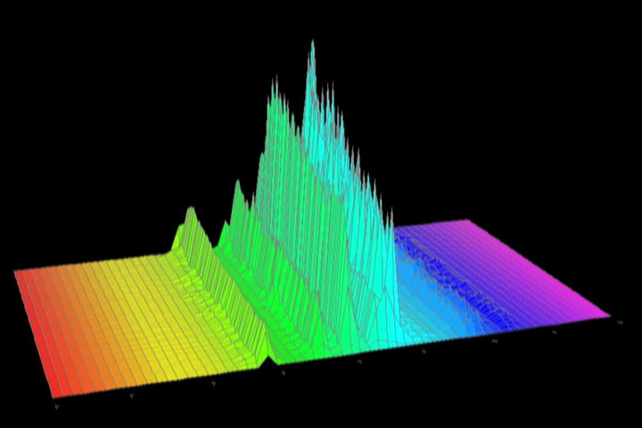

Fill in the correct answer while you watch the DVD.

- A SINE wave is a “perfect” wave that does not occur in nature.

- The height of a wave depicts how LOUD a sound is.

- The height or volume of a wave is known as its Amplitude.

- When we look at the graph of a cello wave, there are many frequencies represented. This is called a COMPLEX wave.

- The frequency that we hear is called the FUNDAMENTAL.

- The other frequencies that we see in the graph are called HARMONICS.

- The fundamental frequency plus the harmonics together produce the unique sound of an instrument called its TIMBRE.

