Where Music Meets Science
DVD
Part 3 – Frequency and Harmonics
Student Study Guide

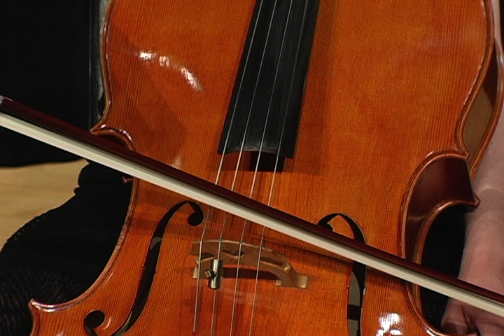

Fill in the correct answer while you watch the DVD.

- A major scale has 8 tones.
- The two most important notes of a scale are numbers 1 and 8 they are known as the TONIC NOTES.
- The 5th note of the scale is known as the DOMINANT.
- The third not of the major scale is the MEDIANT.
- When the 1st, 3rd, and 5th notes of a scale are played together, we hear a CHORD or TRIAD.
- When we hear a cello play A 220, the other frequencies that show up are MULTIPLES of 220 hz.
- Sounds that are multiples of a fundamental frequency are called HARMONICS.
- In the first 7 harmonics of A 220, how many are A’s and how many are E’s? (A) 3 and (E) 2

